Here document and Here string

1) Convert a string to uppercase using:

a) Here document

b) Here string

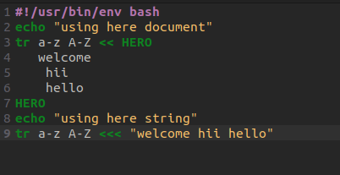

TERMINAL

